**Lab_Day-3 ANP-C9180**

**(Programming Statements)**

1. Using input () function take one number from the user and using ternary operators check whether the number is even or odd

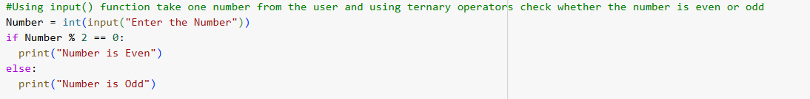

Output:



1. Using input function take two number and then swap the number

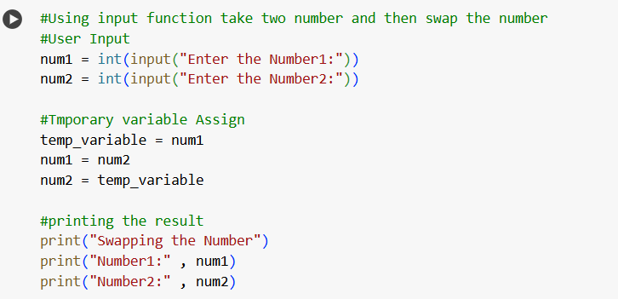

Output:

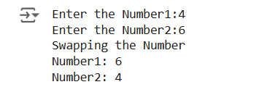

1. Write a Program to Convert Kilometres to Miles

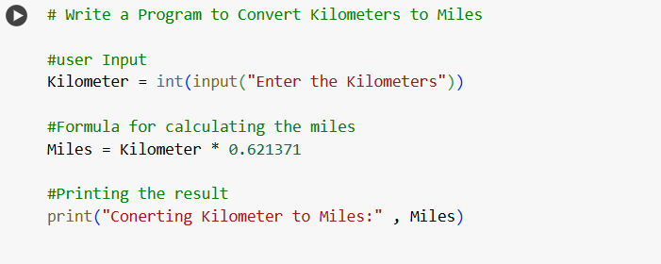

Output:



1. Find the Simple Interest on Rs. 200 for 5 years at 5% per year.

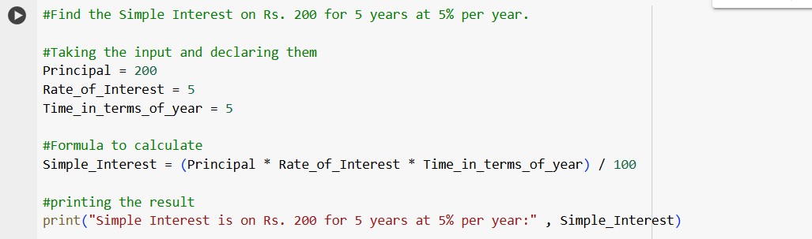

1. Output:

